CS 3321

LMS Database Project

**Project Report**

**Team Members:**

Carolann Mora, Adnan Rashid, Jheysson Menendez, Jesus Lozano, Alex Nino

**Abstract:**

This database application will store and display crucial student data such as personal data, courses and course grades. The students will use the application to view information about their school status. Information will only be updated by administrators including teachers and school staff.

**Mission Statement:**

The purpose of this database is to allow students to have an easy-to-access application to view their information in one place. Administrators will use this database to update students’ information such as grades and course registrations.

**Team LIfe Cycle Model:**

Agile processing. A group of programmers worked on SQL, GUI and database execution. A group of documenters worked on diagrams and organization.

**UML Diagrams:**

**Use Case Diagram**

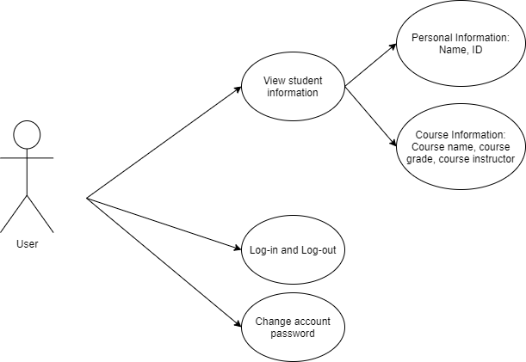

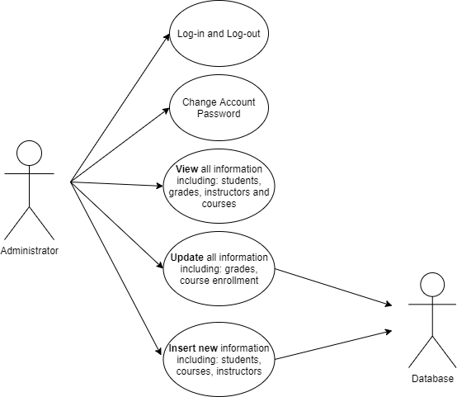

**Class Diagram:**

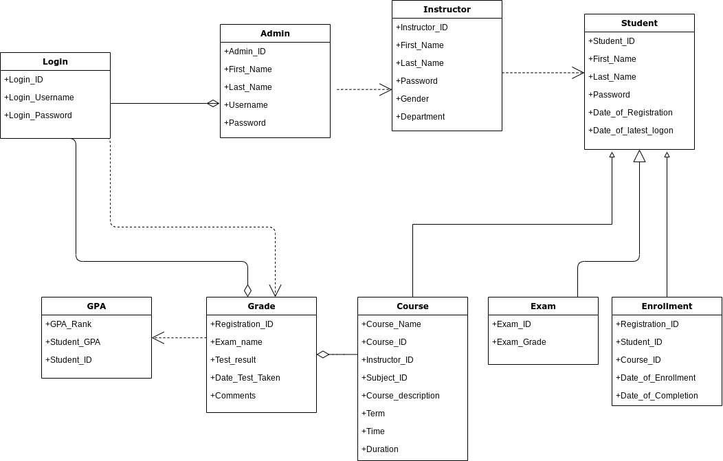

**Architecture Diagram:**

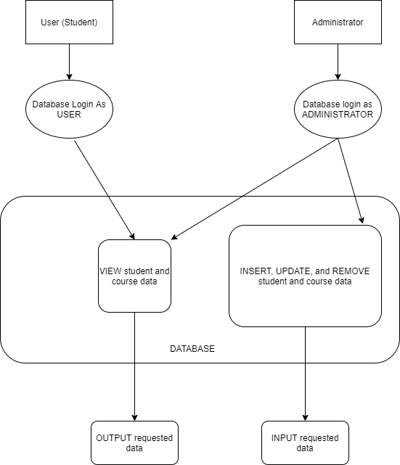

**Student and Course Information example:**

admin table

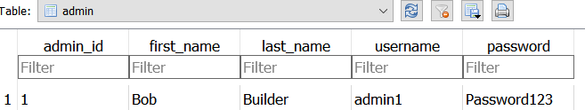

students table

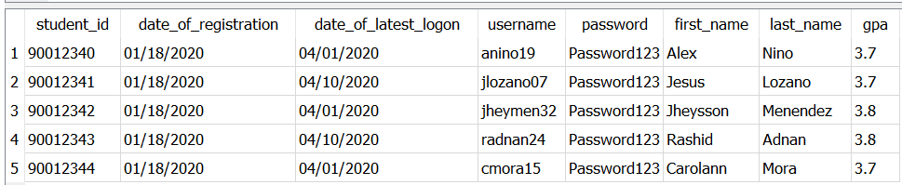

course_instructor table

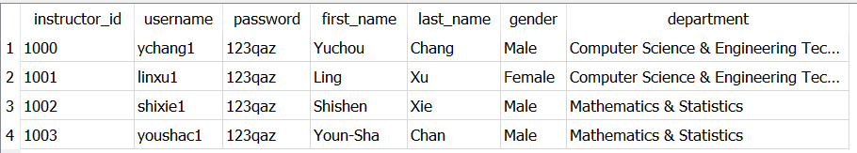

Subjects table

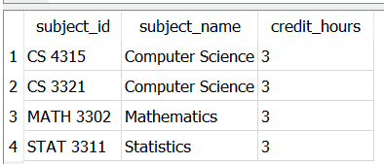

Courses table

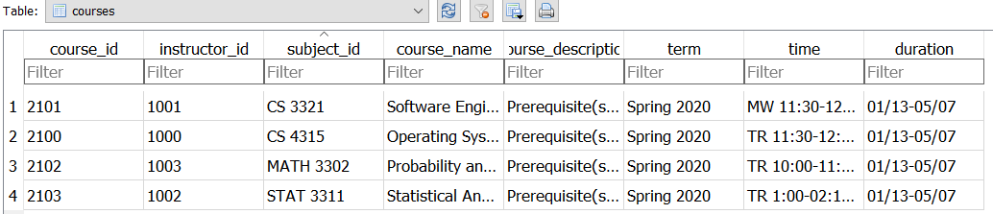

Student_course_enrollment table

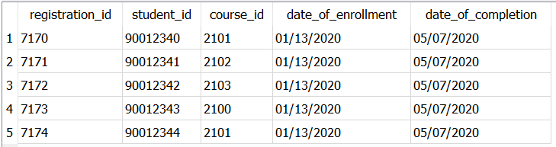

Student_grade table

